Antique Dealers: the British Antiques Trade in the 20th century, a cultural geography – a university research project.
Seeking Help from Family & Local Historians!
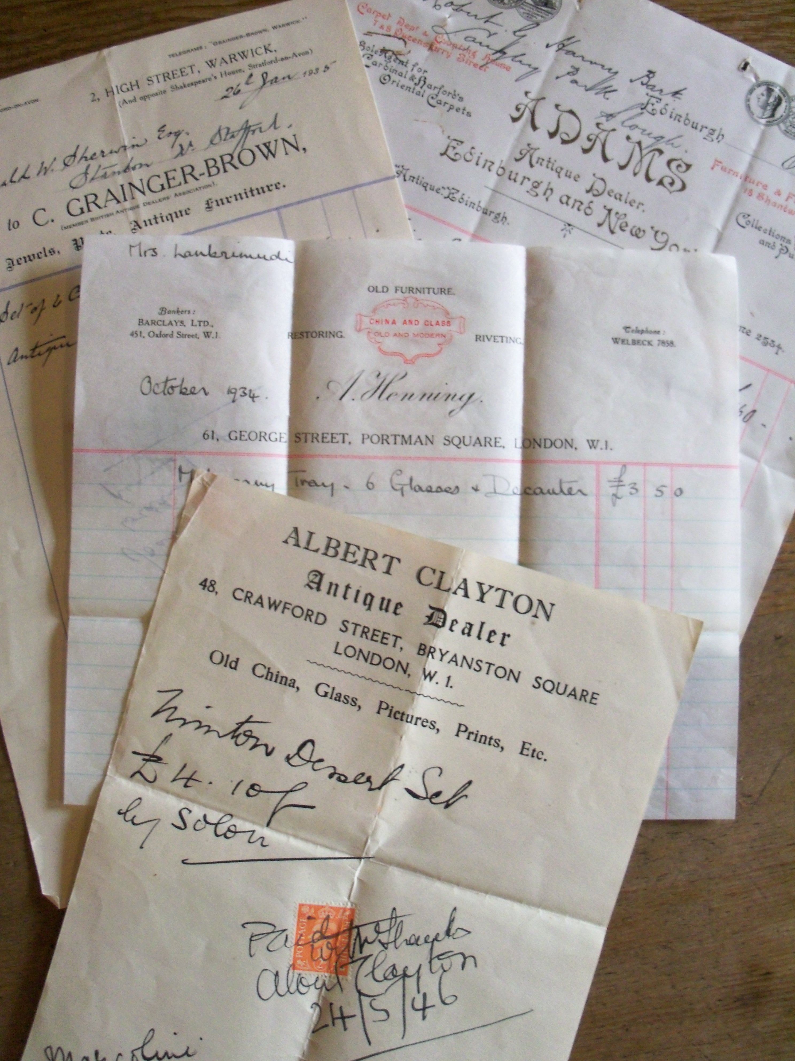
The ‘Antique Dealers’ project is the first time that the history of the modern trade in antiques has been subject to sustained academic, critical study. This 30 month research project, which started in September 2013, is funded by the Arts & Humanities Research Council (AHRC) one of the leading academic research funding bodies in the UK. The project is based at the University of Leeds and is led by Dr Mark Westgarth as Principal Investigator (PI), with Dr Eleanor Quince (University of Southampton) Co-investigator (CI) and Elizabeth Jamieson (University of Leeds) Research Fellow (RF). It aims to document, map and contextualize the antique trade as it has evolved and developed in Britain in the 20th century.
The project team are looking for help to gather information on antique dealers trading in the 20th century for the project database. Your information could eventually end up on the new interactive public website for the project. You will be a valuable part of an international research project and your contribution to the project, however small, will be fully and publically acknowledged on the project website. This is an exciting opportunity to be involved in a university-based research project and to help assemble the mass of information needed for the public database. You do not need to have any knowledge of the antique trade; family history, local history, research experience is an advantage, but not a requirement.
Let’s get mapping the Trade!
For more information on the project and on how to get involved see:
www.antiquedealers.leeds.ac.uk
Or email: antiquedealers@leeds.ac.uk

